Best Practices for Selecting a Predicate Device to Support a Premarket Notification [510(k)] Submission

Draft Guidance for Industry and Food and Drug Administration Staff
DRAFT GUIDANCE
This draft guidance document is being distributed for comment purposes only.

Document issued on September 7, 2023.

You should submit comments and suggestions regarding this draft document within 90 days of publication in the Federal Register of the notice announcing the availability of the draft guidance. Submit electronic comments to https://www.regulations.gov. Submit written comments to the Dockets Management Staff, Food and Drug Administration, 5630 Fishers Lane, Room 1061, (HFA-305), Rockville, MD 20852-1740. Identify all comments with the docket number listed in the notice of availability that publishes in the Federal Register.

For questions about this document regarding CDRH-regulated devices, contact the Office of Product Evaluation and Quality, Office of Regulatory Programs, Division of Regulatory Programs 1 (Submission Support) at 301-796-5640. For questions about this document regarding CBER-regulated devices, contact the Office of Communication, Outreach, and Development (OCOD) at 1-800-835-4709 or 240-402-8010, or by email at ocod@fda.hhs.gov.

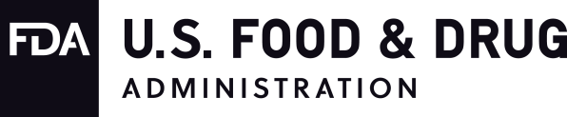
U.S. Department of Health and Human Services
Food and Drug Administration Center for Devices and Radiological Health Center for Biologics Evaluation and Research

Preface

Additional Copies CDRH
Additional copies are available from the Internet. You may also send an email request to CDRH- Guidance@fda.hhs.gov to receive a copy of the guidance. Please include the document number GUI00020006 and complete title of the guidance in the request.

CBER
Additional copies are available from the Center for Biologics Evaluation and Research (CBER), Office of Communication, Outreach, and Development (OCOD), 10903 New Hampshire Ave., Bldg. 71, Room 3128, Silver Spring, MD 20993-0002, or by calling 1-800-835-4709 or 240-402- 8010, by email, ocod@fda.hhs.gov, or from the Internet at https://www.fda.gov/vaccines-blood- biologics/guidance-compliance-regulatory-information-biologics/biologics-guidances.

Table of Contents
- Introduction 1
- Background 2
  - The 510(k) Process 2
  - 510(k) Modernization 3
- Scope 4
- How to use this guidance 4
- Best practices for selecting a predicate device 6
  - Predicate devices cleared using well-established methods 7
  - Predicate devices meet or exceed expected safety and performance 8
  - Predicate devices without unmitigated use-related or design-related safety issues 9
  - Predicate devices without an associated design-related recall 10
- Improving the Transparency of Predicate Devices 11
- Examples 12

1 Best Practices for Selecting a Predicate
2 Device to Support a Premarket
3 Notification [510(k)] Submission
4
5 Draft Guidance for Industry and
6 Food and Drug Administration Staff
7
This draft guidance, when finalized, will represent the current thinking of the Food and Drug Administration (FDA or Agency) on this topic. It does not establish any rights for any person and is not binding on FDA or the public. You can use an alternative approach if it satisfies the requirements of the applicable statutes and regulations. To discuss an alternative approach, contact the FDA staff or Office responsible for this guidance as listed on the title page.
8
9
10
11
12
13
14

I. Introduction
- FDA developed this document to provide guidance to industry and FDA staff about best
- practices in selecting a predicate device for premarket notification [510(k)] submissions.
- Specifically, this guidance recommends four (4) best practices to employ when selecting a
- predicate device used to support a 510(k) submission. The recommendations provided in this
- guidance are not intended to propose any changes to applicable statutory and regulatory
- standards, such as how FDA evaluates substantial equivalence, or the applicable requirements,
- including the requirement for valid scientific evidence. FDA developed this guidance to improve
- the predictability, consistency, and transparency of the 510(k) premarket review process. This
- guidance and associated recommendations are consistent with and are intended to be used in
- conjunction with the FDA guidance “The 510(k) Program: Evaluating Substantial Equivalence in
- Premarket Notifications [510(k)]”¹ (hereinafter, 510(k) Program Guidance) and other relevant
- FDA guidances on 510(k) submissions. 28
- In general, FDA’s guidance documents do not establish legally enforceable responsibilities.
- Instead, guidances describe the Agency’s current thinking on a topic and should be viewed only
- as recommendations, unless specific regulatory or statutory requirements are cited. The use of
- the word should in Agency guidances means that something is suggested or recommended, but
- not required.
34

¹ Available at https://www.fda.gov/regulatory-information/search-fda-guidance-documents/510k-program- evaluating-substantial-equivalence-premarket-notifications-510k.

II. Background

A. The 510(k) Process
- The framework under which FDA regulates medical devices was put into place when Congress
- enacted the Medical Device Amendments (Pub. L. 94-295) to the Federal Food, Drug, and
- Cosmetic Act (FD&C Act) on May 28, 1976. Under section 510(k) of the FD&C Act, a
- manufacturer must submit a premarket notification (often referred to as a 510(k)) to FDA at least
- 90 days before introducing, or delivering for introduction, a device into interstate commerce for
- commercial distribution so the Agency can determine whether or not the device meets the criteria
- for market clearance (sections 510(k), 510(n), and 513(i) of the FD&C Act). A 510(k) is required
- for devices intended for human use, for which a premarket approval application (PMA) is not
- required, unless the device is exempt from the 510(k) requirements of the FD&C Act and does
- not exceed the relevant limitations of exemptions in the device classification regulations. 47
- A 510(k) is a marketing submission made by a manufacturer to FDA to demonstrate that the
- device to be marketed is substantially equivalent to a “predicate device” (section 513(i) of the
- FD&C Act and 21 CFR 807.92(a)(3)-(6)). Substantial equivalence is rooted in a comparison
- between the “new device”² and predicate device(s).³ 52
- The Agency bases its decision on whether the device is substantially equivalent (SE) to a
- predicate device using the statutory criteria in section 513(i) of the FD&C Act. For FDA to find a
- new device SE to a predicate device, FDA must first find that the new device and predicate
- device have the same intended use. FDA must then find that the new device and predicate device
- have the same technological characteristics, or if they do not, that the different technological
- characteristics⁴ of the new device do not raise different questions of safety and effectiveness and
- that the new device is as safe and effective as a predicate device. FDA conducts this evaluation
- by reviewing the proposed scientific methods for evaluating new/different technological
- characteristics’ effects on safety and effectiveness and accompanying performance data to
- determine whether the methods are acceptable and whether the data demonstrates SE. A new
- device requiring premarket notification cannot be introduced into interstate commerce for

² For purposes of this guidance, a “new device” means a device within the meaning of section 201(h) of the FD&C Act that is not legally marketed. It can be either a completely new device (i.e., one that has not received FDA’s marketing authorization) or a modification of a legally marketed device that would require a new 510(k).
³ A predicate device is a legally marketed device. Under 21 CFR 807.92(a)(3), a legally marketed device to which a new device may be compared for a determination regarding substantial equivalence is a device that was legally marketed prior to May 28, 1976, or a device which has been reclassified from class III to class II or I, or a device which has been found to be substantially equivalent through the 510(k) premarket notification process. Moreover, “[a] device may not be found to be substantially equivalent to a predicate device that has been removed from the market at the initiative of [FDA] or that has been determined to be misbranded or adulterated by a judicial officer.” Section 513(i)(2) of the FD&C Act.
⁴ For purposes of an SE determination, “‘different technological characteristics’ means, with respect to a device being compared to a predicate device, that there is a significant change in the materials, design, energy source, or other features of the device from those of the predicate device.” Section 513(i)(1)(B) of the FD&C Act.

- commercial distribution until FDA issues an order stating that the device has been determined to
- be SE (section 513(f)(1) of the FD&C Act).⁵ 66

B. 510(k) Modernization
- In April 2018, CDRH issued the Medical Device Safety Action Plan: Protecting Patients,
- Promoting Public Health⁶ (herein referred to as the “Safety Action Plan”) to communicate
- CDRH’s vision for modernizing measures to improve the safety of medical devices while
- continuing to create more efficient pathways to bring critical devices to patients. The Safety
- Action Plan describes the efforts underway to modernize the 510(k) program. 73
- In November 2018, FDA announced transformative new steps to modernize FDA’s 510(k)
- program to advance the review of the safety and effectiveness of medical devices. In connection
- with this announcement, FDA also requested public feedback on these steps to continue to
- modernize the framework for 510(k) review while promoting innovation and improving safety
- by driving innovators toward reliance on more modern predicate devices or objective
- performance criteria when they seek to bring new devices to the market and ultimately to
- patients. FDA indicated that it is looking at ways to promote the use of more recent predicates
- because it believes that newer devices should be compared to the benefits and risks of more
- modern technology.
83
- To advance these goals, FDA discussed several potential options for 510(k) modernization. The
- statement discussed that the Agency considered making public on its website those cleared
- devices that demonstrated substantial equivalence to older predicate devices. FDA also
- considered focusing on predicates that were more than ten (10) years old as a starting point, so
- the public was made aware of those technologies. FDA’s goal in focusing on older predicates
- was to encourage manufacturers to continually offer patients devices with the latest
- improvements and advances. FDA issued a public notice on January 22, 2019⁷ on FDA’s website
- that requested public comment on this proposal. 92
- FDA reviewed all comments submitted to the docket and acknowledges that the initial proposal
- of focusing only on older predicates may not optimally promote safer and more effective
- devices. For example, if selecting a predicate for an implant, older devices may potentially have
- long-term safety and effectiveness data that establishes a history of safe and effective use.
- Conversely, when selecting a predicate for a device that includes software, a more recently

⁵ Under section 510(k) of the FD&C Act, premarket notification is required for devices that are not subject to a premarket approval application, unless the device is exempt from the 510(k) requirements of the FD&C Act and does not exceed the limitations of exemptions for each of the device classification regulations (e.g., 21 CFR Parts 862-892).
⁶ Available at https://www.fda.gov/about-fda/cdrh-reports/medical-device-safety-action-plan-protecting-patients- promoting-public-health.
⁷ Available at https://wayback.archive- it.org/7993/20190206202131/https://www.fda.gov/AboutFDA/CentersOffices/OfficeofMedicalProductsandTobacco
/CDRH/CDRHReports/ucm604500.htm. Public comments submitted can be searched under the docket FDA-2018- N-4751, available at https://www.regulations.gov/docket/FDA-2018-N-4751/comments.

- cleared device could include modern safety features due to rapid technological advances that
- affect cybersecurity, interoperability, and modern software architectures. 100
- After considering the docket comments, FDA believes that it may be more appropriate to
- modernize the 510(k) process with respect to the use of predicate devices by focusing on
- utilizing best practices when selecting a predicate device rather than just their age. Therefore,
- FDA is issuing this draft guidance to propose ways to encourage the use of best practices when
- selecting a predicate device. 106
- FDA developed this draft guidance to propose factors for consideration as best practices for
- choosing a predicate device. These best practices include consideration of the characteristics of
- predicate devices rather than focusing on the age of the predicate. FDA believes that this will
- encourage the evolution of safer and more effective medical devices in the 510(k) program over
- time. Additionally, FDA believes that identification of the characteristics of predicate devices
- used to support a 510(k) submission in the accompanying 510(k) Summary may provide
- additional transparency to the public for devices subject to 510(k) requirements.⁸ 114

III. Scope
- This guidance provides recommendations to industry and FDA staff about the best practices of
- choosing a predicate device for a 510(k) submission. This guidance is intended to be used in
- conjunction with the 510(k) Program Guidance.⁹ The recommendations provided in this
- guidance are not intended to propose any changes to applicable statutory and regulatory
- standards, such as how FDA evaluates substantial equivalence, or the applicable requirements,
- including the requirement for valid scientific evidence. FDA developed this guidance to improve
- the predictability, consistency, and transparency of the 510(k) premarket review process. 123
- This guidance is also not intended to supplant existing device-specific guidance but may cover
- broader areas not addressed in device-specific guidances. 126

IV. How to use this guidance
- This guidance is intended to guide submitters through the best practices in selecting a predicate
- device for a 510(k) submission. This guidance is intended to be used while a submitter is
- preparing their 510(k) submission to assist with the identification of potential predicate device(s)
- to support their device’s substantial equivalence to a legally marketed device. Based on FDA’s
- experience in reviewing 510(k) submissions, the Agency is aware that many submitters include

⁸ Consistent with the 510(k) Program Guidance and as specified in 21 CFR 807.92(a)(6), the 510(k) Summary shall contain the following information: “If the device has the same technological characteristics (i.e., design, material, chemical composition, energy source) as the predicate device identified in [21 CFR 807.92(a)(3)], a summary of the technological characteristics of the subject device in comparison to those of the predicate device. If the device has different technological characteristics from the predicate device, a summary of how the technological characteristics of the device compare to a legally marketed device identified in [21 CFR 807.92(a)(3)].”
⁹ Available at https://www.fda.gov/regulatory-information/search-fda-guidance-documents/510k-program-

- in their 510(k) submission a completed 510(k) flowchart with a discussion describing why the
- submitter believes their device is substantially equivalent to the predicate device.¹⁰ 135
- When considering the selection of predicate devices during 510(k) submission preparation,
- submitters should consider the list of legally marketed devices that they believe have the same
- intended use as the subject device and when any differences in technological characteristics do
- not raise different questions about safety and effectiveness, hereafter referred to as a “valid
- predicate device.”^{11,} ¹² FDA recommends narrowing this list of valid predicate device(s) to the
- predicate device¹³ identified by the submitter to support the 510(k) submission using the best
- practices outlined in Section V of this guidance, in conjunction with the 510(k) Program
- Guidance.¹⁴ A visual representation of this concept is illustrated in Figure 1 below. 144
145

¹⁰ For example, FDA has guidance on the “Format for Traditional and Abbreviated 510(k)s,” available at https://www.fda.gov/regulatory-information/search-fda-guidance-documents/format-traditional-and-abbreviated- 510ks. Submitters could include such an assessment in Section 12 (Substantial Equivalence Discussion) of their 510(k) submission.
¹¹ Consistent with sections 510(k), 510(n), and 513(i) of the FD&C Act and the 510(k) Program Guidance, while submitters propose a predicate device in their 510(k) submission, FDA determines whether a subject and predicate device are substantially equivalent. This determination includes whether a valid predicate device exists for the subject device.
¹² Consistent with the 510(k) Program Guidance, if FDA has established special controls applicable to the device type, the 510(k) would also need to demonstrate that the proposed device meets the relevant special controls for the device to be classified into class II.
¹³ Consistent with the 510(k) Program Guidance, a submitter may use multiple predicate devices to help demonstrate substantial equivalence in certain circumstances. Submitters sometimes choose to do this when combining features from two or more predicate devices with the same intended use into a single new device, when seeking to market a device with more than one intended use, or when seeking more than one indication for use under the same intended use. Additionally, while FDA does not consider reference devices to be predicate devices, reference devices can be used to support a 510(k) submission beyond Decision 4 in the 510(k) flowchart (See Appendix A in the 510(k) Program Guidance). For example, reference devices can be used to support scientific methodology or standard reference values at Decision 5a in the 510(k) flowchart.
¹⁴ Available at https://www.fda.gov/regulatory-information/search-fda-guidance-documents/510k-program-

146
147
148
149
150
151
152
153
154
155
156
157
158
159
160
161
162
163
164
165
166

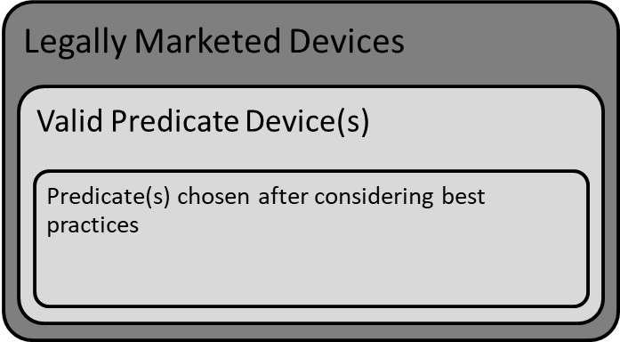
Figure 1. Visual depiction of the relevant terminology used in this guidance.

FDA recommends the submitter include within their 510(k) submission how they used the best practices identified in this guidance in selecting the predicate device(s) used to support the 510(k) submission. For example, if a valid predicate device consistent with the best practices identified in this guidance is not available, FDA recommends describing in the 510(k) submission how any known concerns with the valid predicate device have been mitigated with the subject device (e.g., design features, performance testing). FDA also recommends that the submitter summarize how the best practices were utilized in the selection of the predicate device used to support the 510(k) submission in the 510(k) Summary (See Section VI of this guidance). These recommendations are intended to aid the submitter in selecting a predicate for their device and help provide additional transparency to the public in the 510(k) summary if the 510(k) submission is cleared by FDA.

Best practices for selecting a predicate device
FDA identifies all devices cleared through the 510(k) process in the publicly available FDA 510(k) Premarket Notification Database.¹⁵ This online database is updated monthly by FDA. Most submitters likely start with basic administrative information to identify valid predicate device(s), including but not limited to the:
  - Trade names of similar devices;

167 | - Manufacturer(s) of similar devices;
168 | - 510(k) numbers for similar devices; and
169 | - Searching of classification information (e.g., product codes, classification regulation) for
170 | similar devices.
171

¹⁵ Available at https://www.accessdata.fda.gov/scripts/cdrh/cfdocs/cfpmn/pmn.cfm.

- Once legally marketed devices have been identified, FDA recommends reviewing the publicly-
- available 510(k) Summary¹⁶ and Indications for Use documents for each device being considered
- by the submitter as a valid predicate device. In addition to these basic administrative items, FDA
- recommends submitters apply the best practices identified below when selecting a predicate
- device to support the 510(k) submission.

A. Review regulatory strategy, including rationale for predicate

selection, with the FDA during pre-submission meeting
- A pre-submission meeting allows the FDA to evaluate predicate selection on a case-by-case basis, and it allows submitters to propose verification and validation methods that will demonstrate equivalent or better safety and performance of a new device. Older devices may pre-date current standards for safety and performance, but we cannot automatically assume that the older device is inferior to the newer device that was evaluated against the current standards. A medical device or IVD that has been on the market longer may have equivalent safety and performance when compared to a potential predicate that was recently 510(k)-cleared.

- If a well-established method for evaluating safety and/or performance is recognized by the FDA, then the device should be evaluated against the recognized standard. Submitters can identify recognized standards that are applicable to each product classification by entering the product classification into the recognized standards database. For example, if a submitter is developing a clinical electronic thermometer the product classification code is “FLL.” If that code is entered into the recognized consensus standards database, there are six recognized standards identified:
- 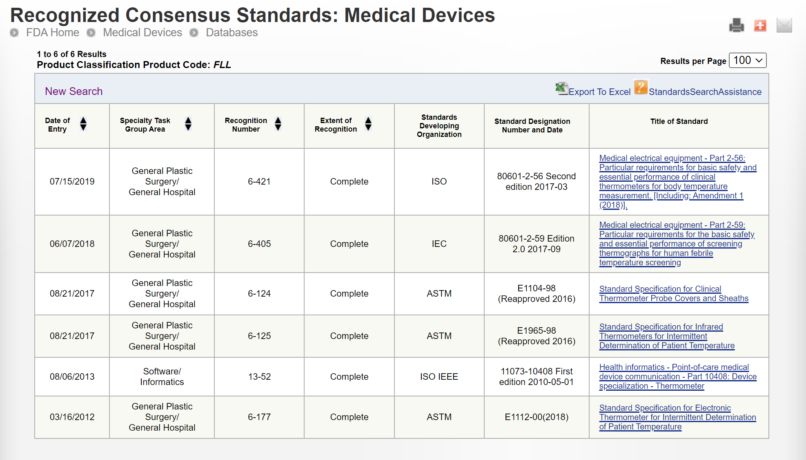
- Only some of the above standards may apply to a new submission, but the submitter should identify

- which standards are applicable and why in the pre-submission. If the submitter chooses not to discuss the testing methods and predicate selection with the FDA in a pre-submission, then it may be determined during the substantive review that applicable recognized consensus standards were not applied to the subject device and additional testing is needed. Another possible outcome is that the predicate selected has inferior performance and it is not able to pass the acceptance criteria outlined in the recognized consensus standards. In this case, any side-by-side testing used to demonstrate equivalence performance to the predicate selected would not be sufficient to obtain 510(k) clearance. The submitter could submit side-by-side testing and testing in accordance with the recognized consensus standard, but that would not be the least burdensome pathway for 510(k) clearance.

B. Predicate devices meet or exceed expected safety and
- performance
- FDA considers it a best practice to select a valid predicate device that continues to perform
- safely and as intended by the manufacturer during use in its intended environment of use
- whenever possible. FDA recommends selecting a valid predicate device after considering how
- any reported medical device-related adverse events, malfunctions, or deaths may have a role in
- the safety and effectiveness of the device. New information about a device’s safety and/or
- effectiveness, including unanticipated adverse events, may become available once the device is
- more widely distributed and used commercially. Also, subsequent changes made to the device,
- including material changes, or its manufacturing process may lead to unanticipated effects that
- cannot be comprehensively captured during premarket review.²² This new information may
- include, but is not limited to, a newly recognized type of adverse event associated with a medical
- device, an increase in the severity or frequency of a known adverse event, new product-product
- interactions, or device malfunctions. 218
- Once the submitter has identified a list of valid predicate devices, FDA recommends conducting
- a search of post-market surveillance (PMS) data for any reported injury, deaths, or malfunctions. The PMS search should include other markets where the similar devices are marketed, and the following FDA databases:
- • Manufacturer and User Facility Device Experience (MAUDE) Database;²³
- • Medical Device Reporting (MDR) Database;²⁴
- • MedSun Reports Database,²⁵ and
- • Total Product Life Cycle (TPLC) Database.
- FDA recommends searching each of the above databases for any reports of unexpected injury,
- deaths, or malfunctions associated with the available valid predicate devices. For example, when
- selecting a predicate device for an infusion pump, if the database search reveals
- reports of battery failures related to the predicate device that resulted in serious injuries to the
- operator, such events could suggest fundamental design issues with this valid predicate device.

²² The regulatory criteria for when a premarket notification submission is required for a change to an existing device are outlined in 21 CFR 807.81(a)(3). For more information regarding when a premarket modification submission is required refer to the FDA guidance titled, “Deciding When to Submit a 510(k) for a Change to an Existing Device,” available at https://www.fda.gov/regulatory-information/search-fda-guidance-documents/deciding-when-submit- 510k-change-existing-device, and the FDA guidance titled, “Deciding When to Submit a 510(k) for a Software Change to an Existing Device,” available at https://www.fda.gov/regulatory-information/search-fda-guidance- documents/deciding-when-submit-510k-software-change-existing-device.
²³ Available at https://www.accessdata.fda.gov/scripts/cdrh/cfdocs/cfmaude/search.cfm.
²⁴ Available at https://www.accessdata.fda.gov/scripts/cdrh/cfdocs/cfmdr/search.cfm.
²⁵ Available at https://www.accessdata.fda.gov/scripts/cdrh/cfdocs/medsun/searchreporttext.cfm.
²⁶ Available at https://www.accessdata.fda.gov/scripts/cdrh/cfdocs/cftplc/tplc.cfm.

230  231 | In this example of an infusion pump, battery failures could also be the result of manufacturing or supplier quality issues. If reason for failures is unknown, the FDA recommends selection of a different valid predicate device for the 510(k) submission whenever possible. If the reason for failures is known to be manufacturing or supplier quality issues, then the submitter will need to address these potential quality issues in their own manufacturing process controls or supplier quality controls. If another valid predicate device is not available, FDA recommends that the
232 | submitter describe in the 510(k) submission how the subject device mitigates the known
233 | concerns with the predicate device used to support the 510(k) submission.
234
235 | C. Predicate devices without unmitigated use­related or design­
236 | related safety issues
237 | FDA recommends selecting a valid predicate device that does not have unmitigated use-related
238 | or design-related safety issues, including consideration of emerging signals or safety
239 | communications.²⁶ New information about a device’s safety and/or effectiveness can become
240 | available once the device is more widely distributed and used. This new information could
241 | represent a signal and may include information related to device malfunctions or patient injuries
242 | potentially related to improper device use or design.
244 | Consistent with the FDA guidance “Public Notification of Emerging Postmarket Medical Device
245 | Signals (“Emerging Signals”),”²⁷ an emerging signal is new information about a device that
246 | supports a new causal association or a new aspect of a known association between a device and
247 | an adverse event or set of adverse events and for which FDA has conducted an initial evaluation
248 | and determined that the information has the potential to impact patient management decisions
249 | and/or the known benefit-risk profile of the device. An emerging signal may be associated with
250 | one product from one manufacturer, one type of product or similar products from multiple
251 | manufacturers, or multiple different product types from multiple different manufacturers (e.g.,
252 | materials issues). Information about emerging signals and safety communications is available on
253 | the Medical Device Safety²⁸ and CBER Safety & Availability (Biologics)²⁹ websites. FDA
254 | recommends reviewing any safety signals, emerging signals, or other safety information
255 | available prior to selecting a valid predicate device to support the 510(k) submission.
257 | Once the submitter has identified a list of valid predicate devices, FDA recommends conducting
258 | a search of the Medical Device Safety and CBER Safety & Availability (Biologics) websites to
259 | assess whether any of the valid predicate devices have an associated use-related or design-related
260 | safety issue. For example, a signal was reported for duodenoscopes describing challenges in the
261 | adequacy of reprocessing instructions that resulted in a potential for disease transmission.³⁰ This
262 | signal resulted in an effort to replace traditionally reprocessed duodenoscopes with
263 | duodenoscopes which had innovative designs to enhance safety, including designs with
264 | disposable caps or distal ends. FDA considers it a best practice to select a valid predicate device
265 | that is not associated with emerging signals or safety communications that relate to unmitigated
266  267 | use-related or design-related safety issues whenever possible.
²⁶ Available at https://www.fda.gov/medical-devices/medical-device-safety.
²⁷ Available at https://www.fda.gov/regulatory-information/search-fda-guidance-documents/public-notification-
emerging-postmarket-medical-device-signals-emerging-signals.
²⁸ Available at https://www.fda.gov/medical-devices/medical-device-safety.
²⁹ Available at https://www.fda.gov/vaccines-blood-biologics/safety-availability-biologics.
³⁰ Available at https://www.fda.gov/medical-devices/safety-communications/use-duodenoscopes-innovative-
 | designs-enhance-safety-fda-safety-communication.

243

256

D. Predicate devices without an associated design­related recall
- FDA recommends selecting a valid predicate device that has not been subject to a design-related
- recall.³¹ Recalls are typically voluntary actions taken by a manufacturer or may be requested by
- FDA to correct or remove a violative product from the market.³² A violative product is one in
- violation of the laws that FDA administers and against which FDA would initiate legal action.
Recalls can occur due to design defects, manufacturing defects, supplier quality issues, labeling defects, or security vulnerabilities. If the cause of the recall is known to be the result of manufacturing defects, supplier quality issues, labeling defects, or security vulnerabilities then the submitter will need to address these potential quality issues in their own quality system.

- Design-related recalls can indicate a fundamental flaw with the design of the device as cleared
- and commercially distributed. Design controls under 21 CFR 820.30 include a framework that
- requires manufacturers subject to these requirements to establish and maintain procedures to
- control the design of the device in order to ensure that specified design requirements are met.^{33,34}
- When a design-related recall has been conducted for a device, adequate design control
- procedures, including but not limited to design input, output, verification, validation, and transfer
- may not have been adequately implemented through the design process. In some instances, the
- underlying root cause of the design related issues identified as part of a design-related recall may
- not be available or a correction of these design-related issues may not be possible. Further,
- although the methods and performance data provided in the 510(k) submission for the valid
- predicate device subject to a subsequent design-related recall were sufficient to support a
- substantial equivalence determination at that time of 510(k) clearance, utilization of such a valid
- predicate device may not be ideal to use for future 510(k) submissions. 288
- Once the submitter has identified a list of valid predicate devices, FDA recommends conducting
- a search of the Medical Device Recalls Database to assess whether any of the valid predicate
- devices have an associated recall. For example, the recall of a coronary catheter tip for fracture
- could be associated with a change in the manufacturing process or with the materials used in the
- design of the catheter. If a recall is associated with the materials used in the catheter, this could
- be considered a design-related recall when it is due to an inadequacy of that material to meet user

³¹ The Medical Device Recalls Database is available at https://www.accessdata.fda.gov/scripts/cdrh/cfdocs/cfRES/res.cfm, and includes recalls classified since November 2002.
³² While FDA focuses on voluntary recalls conducted under 21 CFR Part 7, FDA may, after providing the appropriate person with an opportunity to consult with the Agency, also require that a manufacturer recall their device when the criteria are met under 21 CFR Part 810.
³³ For devices subject to 510(k) requirements, design controls apply to class II devices and those class I devices listed in 21 CFR 820.30(a)(2).
³⁴ On February 23, 2022, FDA proposed to amend the device Quality System Regulation, 21 CFR Part 820, to align more closely with international consensus standards for devices (87 FR 10119; available at https://www.federalregister.gov/documents/2022/02/23/2022-03227/medical-devices-quality-system-regulation- amendments). Specifically, FDA proposed to withdraw the majority of the current requirements in Part 820 and instead incorporate by reference the 2016 edition of the International Organization for Standardization (ISO) 13485, Medical devices – Quality management systems for regulatory purposes, in Part 820. As stated in that proposed rule, the requirements in ISO 13485 are, when taken in totality, substantially similar to the requirements of the current Part 820, providing a similar level of assurance in a firm’s quality management system and ability to consistently manufacture devices that are safe and effective and otherwise in compliance with the FD&C Act. FDA intends to finalize this proposed rule expeditiously. When the final rule takes effect, FDA will also update the references to provisions in 21 CFR Part 820 in this guidance to be consistent with that rule.

- needs and intended uses. The material used in the design of this catheter and the testing
- conducted on the predicate device did not adequately mitigate against the risk of tip fracture,
- resulting in a design-related recall. FDA considers it a best practice to select a valid predicate
- device that is not associated with a design-related recall whenever possible. 299

VI. Improving the Transparency of Predicate Devices
- The 510(k) Summary is a document that provides an adequate summary of any information
- respecting safety and effectiveness and must include all the elements identified in 21 CFR
- 807.92.³⁵ A 510(k) Summary must be in sufficient detail to provide an understanding of the basis
- for a determination of substantial equivalence (21 CFR 807.92(a)). In Appendix B of the 510(k)
- Program Guidance, FDA describes the requirements of the content to be included in a 510(k)
- Summary, in accordance with 21 CFR 807.92, and provides recommendations on the
- information to be included in a 510(k) Summary to ensure compliance with 21 CFR 807.92 and
- consistency in the level of information conveyed and captured in the 510(k) Summaries that are
- available to the public on FDA’s website. 310
- The current 510(k) content requirements give the submitter the option of submitting a 510(k) Summary as per 21 CFR 807.92, or a 510(k) Statement as per 21 CFR 807.93. The problem with this option is that the public can only obtain more information about the 510(k) submission if they request it directly from the submitter, and they must wait 30 days for the response. Some submitters are slow to respond, ignore the request, or redact more information than is appropriate. Therefore, to improve transparency the FDA is eliminating the option to submit a 510(k) Statement. In addition, all submitters must use the automatically generated 510(k) Summary that is created by the FDA eSTAR template instead of attaching their own Summary. If there is confidential information identified in the Substantial Equivalence (SE) Comparison table, the manufacturer shall provide a redacted SE Comparison table and a copy that is not redacted in the submission as an attachment to the SE Comparison section. The screen capture below shows how information summarizing the safety and performance testing is automatically copied from text boxes with non-confidential information into the automatically generated 510(k) Summary by the FDA eSTAR template.
- 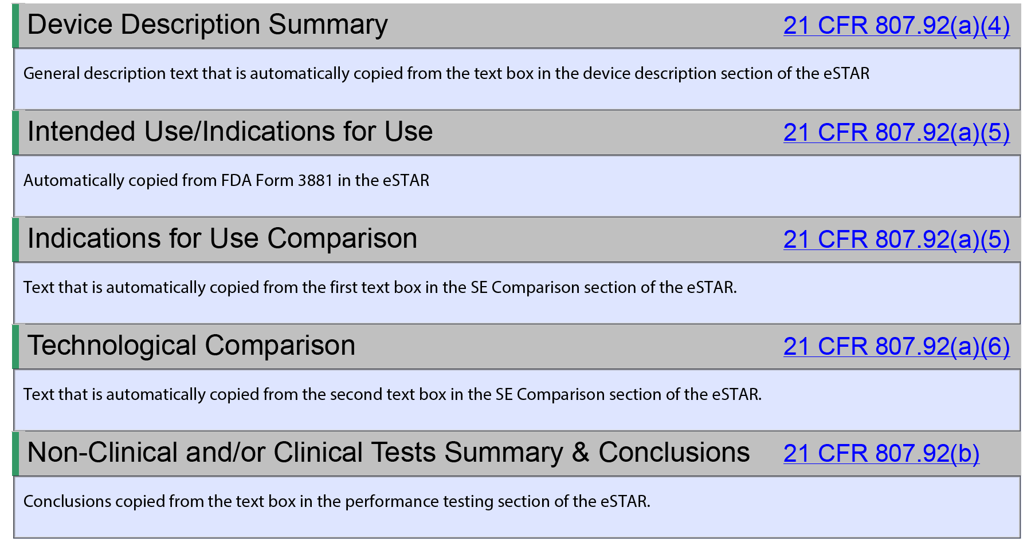

³⁵ As specified in 21 CFR 807.87(h), a 510(k) Statement as described in 21 CFR 807.93 may be provided in lieu of a 510(k) Summary. However, in order to facilitate transparency, FDA encourages all submitters to utilize the 510(k) Summary option.

VII. Examples
- The following are illustrative examples that are intended to exemplify how the best practices
- identified in Section V of this guidance for selecting a valid predicate device can be used. These
- examples do not necessarily account for every possible detail, risk, or consideration that a
- submitter should consider when selecting the predicate device used in support of the 510(k)
- submission.

Summary of Comments
Line Number(s) or Section | Comment (include an explanation) | Proposed New or Edited Language (if applicable)
178-203 (Section V. A.) | Recommend deleting this as a recommended practice. Just because a device was cleared before best practices existed does not automatically result in an inferior design. If the FDA wants to enforce compliance with “well-established methods,” there are three mechanisms for doing this: 1) update the applicable regulation for that type of device or IVD, 2) create a device-specific guidance document or update an existing guidance, and 3) recognize an international standard for that type of device. If there are insufficient resources to make these changes, this should be an issue discussed in pre-submission meetings. | Delete “Best Practice A.”
New Section V. A. | Recommend replacing the current section V. A. with the suggestion that the submitter request a pre-submission meeting with the FDA to discuss the regulatory strategy regarding predicate selection and proposed testing prior to conducting V&V testing. | See new section replacing the “Best Practice A.”
220 | Recommend expanding the search to include other post-market databases rather than just FDA databases. Recommend alignment with Health Canada and adoption of PMS requirements as part of transition to adopting ISO 13485:2016 instead of 21 CFR 820. Results of these searches should be documented in the risk management file and the design history file, but they should not be part of the 510(k) or De Novo submission, because it would slow down the FDA review process and it would have a significant economic impact as it has had in Europe for CE Marking under the MDR and IVDR. | a search of post-market surveillance (PMS) data for any reported injury, deaths, or malfunctions. The PMS search should include other markets where the similar devices are marketed, and
227 & 228 | The FDA databases do not include any information about the total volume of sales for any product and manufacturers are not required to provide this information in adverse event reporting. This is why the EU changed the reporting form used to include sales volume for the past 5 years and the frequency of similar adverse events in each year. Manufacturers do not want to share this information publicly, but it is in the best interest of public health and it is fair if all manufacturers provide this information. It would be a major change in MDR regulations (i.e., 21 CFR 803). | Deleted “a high frequency of”
230 | Added language identifying other possible reasons for adverse events other than design-related reasons. | In this example of an infusion pump, battery failures could also be the result of manufacturing or supplier quality issues. If reason for failures is unknown, the FDA recommends selection of a different valid predicate device for the 510(k) submission whenever possible. If the reason for failures is known to be manufacturing or supplier quality issues, then the submitter will need to address these potential quality issues in their own manufacturing process controls or supplier quality controls.
244 | Added TPLC database, because it includes MAUDE and CDHR Recalls with the ability to search by product classification or device name | Total Product Life Cycle (TPLC) Database
273 | Added language identifying other possible reasons for recalls other than design-related reasons (i.e., manufacturing, supplier, labeling, and security). | , manufacturing defects, supplier quality issues, labeling defects, or security vulnerabilities. If the cause of the recall is known to be the result of manufacturing defects, supplier quality issues, labeling defects, or security vulnerabilities then the submitter will need to address these potential quality issues in their own quality system.
310 | Added language identifying transparency issues created by the use of 510(k) statements. This requires a change in 510(k) regulations. Specifically, the elimination of 21 CFR 807.93. The purpose is to improve consistency, predictability, and transparency of the 510(k) process. | See new paragraph added in this section regarding 510(k) Statements. A screen capture of the FDA eSTAR was also provided to show how information is automatically copied from the eSTAR into an automatically generated 510(k) Summary.
312-339 | Submitters may select a predicate for reasons that are confidential, competitive in nature, or related to the cost of samples used for side-by-side testing. None of these reasons is something that submitters are likely to disclose to the public in a 510(k) Summary. Another problem with this policy is that there is a tremendous range in the number of valid predicates. Some product codes may only have one valid predicate, will other product codes may have nearly 1,000 valid predicates. Requiring a company to document how they selected between 1,000 valid predicates would have a significant economic impact. Elimination of 510(k) Statements and requiring the use of the automatically generated 510(k) Summary is a better approach to achieve predictability, consistency, and transparency into the 510(k) process. | Deleted section requiring narrative summary of the rationale for predicate selection.
345-403 | The examples are too generic and do not provide any real data that is available publicly. If the FDA is going to require submitters to compare adverse event data and design-related recall data, it is important that they show submitters examples of adverse events and recalls that are related to use errors or design-related as well as examples that are not related to use errors or design-related. Otherwise, submitters will incorrectly assume that a device automatically cannot be used as a predicate because there has been an adverse event or a recall. This is similar to the problem the FDA had with choosing an arbitrary cut-off of 10 years for the allowable age of a predicate. To make these examples useful, the FDA needs to provide examples of how this information would also impact the design history file and the risk management file. We do not think this information is appropriate for a 510(k) Summary. | Deleted examples provided.

